**EXPERIMENT- 3**

**Case Study 2 & 5**

**(EMERGENCY ROOM INFORMATION SYSTEM) & (TOUR OPERATING SYSTEM)**

PRE-LAB:

1. Choose the incorrect statement from the following?
2. An attribute of an entity can be composite
3. An attribute of an entity can have more than one value
4. In a row of a relational table, an attribute can have exactly one value or a NULL value
5. In a row of a relational table, an attribute can have more than one value

2. What is meant by maximum cardinality?

3. Which symbol denote derived attributes in the ER Model?

4. What type of entity cannot exist in the database unless another type of entity also exists in the database, but does not require that the identifier of that other entity be included as part of its own identifier?

5. What is meant by recursive relationship?

6. Goals for the design of the logical scheme include

(a) Avoiding data inconsistency (b) Being able to construct query easily

(c) Being able to access data efficiently (d) All of the above

7. An application where only one user accesses the database at a given time is an example of a(n) ________ .

(a) single-user database application (b) multiuser database application

(c) e-commerce database application (d) data mining database application

8. In a one-to-many relationship, the entity that is on the one side of the relationship is called a(n) ________ entity.

(a) parent (b) child (c) instance (d) subtype

9.Explain the relationship between entity, entity class, and entity instance.

10. What is meant by modality?

Top of Form

IN-LAB:

Draw an ER Diagram for a given Case Study 2

## **CASE STUDY 2: EMERGENCY ROOM INFORMATION SYSTEM**

## In our Emergency Room (ER), we have three distinct types of workers: receptionists, nurses, and doctors. Any of the workers can in fact be a patient. Each person in the proposed system, be it a patient or a worker has a last, a first, possibly a middle name, and one or more addresses. An address consists of a country, province, city, street and street number. Each person can have none or more email addresses, none or more telephone numbers.

## The workers work in ER in shifts. A shift consists of start and end time. The shifts do not overlap, but they are consecutive, i.e. there is a shift on at any given time and day. We are assuming that the model we are creating (and eventually the database we will design) covers some extended period of time. Each worker will thus be assigned to many shifts in that period. Exactly two receptionists are assigned to each shift, a group of two or more nurses is assigned to each shift, a group of two or more doctors is assigned to each shift, one of the doctors assigned to a shift is the shift’s triage doctor.

## When a patient comes to ER, it happens during a particular shift. The patient is admitted by a particular receptionist, is seen by the triage doctor of the shift. The patient may be send home, prescribed some medication by the triage doctor and send home, or is staying in ER – in which case the patient is assigned a bed and case doctors (one of the doctors on each shift best qualified for the particular problem of the patient). Each bed is supervised by a single nurse during a shift, but a nurse may supervise many beds, or none at all. The case doctor(s) may prescribe a medication that is administered to the patient by a single nurse in each shift for the duration of the patient taking the medicine. Each medication has a name, and for each patient there may be a different dosage and different number of times a day to take it.

IN-LAB:

Draw an ER Diagram for a given Case Study 5

**CASE STUDY 5: TOUR OPERATING SYSTEM**

The system needs to keep track of people. For each person, it records all his/her address, of which exactly one is designated as the mailing address (so each person has at least one address). Each address consists of country, province/state, city, street, street number, P.O. Box number, and a list (possible empty) of phone numbers to the location of the address and a list (possible empty) of fax numbers to the location of the address. In addition to the list of addresses for each person it records a list (possible empty) of cell phone numbers and a list (possible empty) of email address. Each person in the database can be an old customer (have taken a tour of the company), a current customer (is booked to take a tour or is on a tour right now), a tour guide, an employee (works for the tour company), or any mixture of these (for instance an employee can take a tour and so can be a customer as well, or an employee can work as a tour guide for a particular tour and hence be an employee and a guide at the same time etc.). The sex and age of each person must also be recorded, a date-of-birth is optional for an external worker, a contract reference for each of the tours the guide is doing must be included.

A guide contract references the tour (see below) and the total amount the tour guide will be paid for the tour. The guides do not pay for the accommodation and the meals. The system also keeps track of all tours, past and future. Each tour has a unique designation, itinerary, guide (at least one, but may be more than one), its status (completed, in-progress, in-the-future), and the list of participants (not including the guides). The itinerary consists of list of the dates the tour covers and for each date it includes the place of breakfast, the place of lunch, the place of diner, and the place of accommodation. For each of the places there is a contract reference. Each day in the itinerary also includes and a simple English description of the activities during that day.

An accommodation can be a hotel, or a rented room or rooms from a rental company, or a rented room or rooms from a private person. A meal (breakfast, lunch, dinner) can be in hotel, restaurant, or a private place. The contract for accommodation or meal must bear the date of the contract becomes valid, the date or dates it covers, what the contract is for (accommodation, breakfast, lunch, dinner) if the pricing is per person or per group or per room or per the whole facility, per night or per a certain period and the corresponding price. It also may stipulate the minimum and the maximum of people for the accommodation/meal for each day it covers, financial penalty if less than minimum uses the accommodation. All prices are assumed to be in Canadian dollars, not conversion is involved, regardless where the place is. Each place is identified by a single address. Each provider of accommodation or meal has a unique designation

POST-LAB:

1. Draw ER diagram showing two entities out of which, one is weak entity in a relationship say, a government employee health card and his/her spouse depending on that particular employee. Mention the attributes for the respective entities in the ER diagram.

**Find the relation that exists between the given entities using crow’s foot notation**

1. Given ERD contains Student and Paper entity types connected by a 1-M relationship. The Student entity type have attributes for StdNo (primary key), StdFirstName, StdLastName, StdAdmitSemester, StdAdmitYear, and StdEnrollStatus (full or part-time). The Paper entity type have attributes for PaperNo (primary key), PaperTitle, PaperSubmitDate, PaperAccepted (yes or no), and PaperType (first, second,proposal, or dissertation). Add a 1-M relationship from Student to Paper.

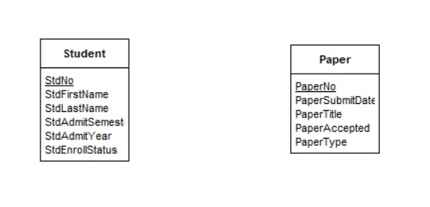

1. Given ERD contains the Order and Customer entity types connected by a 1-M relationship from Customer to Order. Choose an appropriate relationship name using your common knowledge of interactions between customers and orders. Define minimum cardinalities so that an order is optional for a customer and a customer is mandatory for an order. For the Customer entity type, add attributes CustNo (primary key), CustFirstName, CustLastName, CustStreet, CustCity, CustState, CustZip, and CustBal (balance). For the Order entity type, add attributes for the OrdNo (primary key), OrdDate, OrdName, OrdStreet, OrdCity, OrdState, and OrdZip.

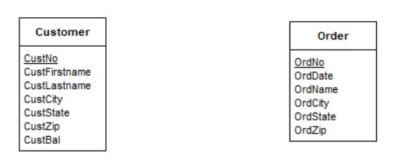

1. Given ERD contains the LabVisit and Patient entity types connected by a 1-M relationship from Patient to LabVisit. Choose an appropriate relationship name using your common knowledge of interactions between patients and lab visits. Define minimum cardinalities so that a patient is required for a lab visit. For the Patient entity type, attributes are PatNo (primary key), PatLastName, PatFirstName, PatDOB (date of birth). For the LabVisit entity type, attributes for the LVNo (primary key), LVDate, LVProvNo, and optional LVOrdNo (for orders from physicians).

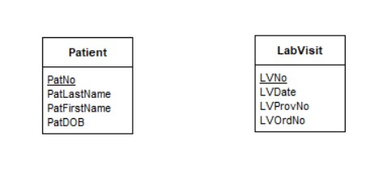

1. Given ERD contains the Paper and Evaluator entity types. The Paper entity type have attributes for PaperNo (primary key), PaperTitle, PaperSubmitDate, PaperAccepted (yes or no), and PaperType (first, second,proposal, or dissertation).The Evaluator entity type should have attributes for EvalNo (primary key), EvalFirstName, EvalLastName, EvalEmail, and EvalOffice. Add the required relationship from Paper to Evaluator

